BRAZIL
Superior Court of Justice – 2016
Public Ministry v. Pandurata Alimentos LTDA
Advertising directed to children
Issue | In 2007, the Alana Institute filed a complaint before the public prosecutor of Sao Pablo since an abusive advertising campaign of the food product “Gulosos” was being directed at children. Gulosos is a brand that belongs to Bauducco, a trademark owned by Pandurata.  The advertising campaign was called “It’s Shrek Time”, and it consisted of obtaining a collectable Shrek watch, provided that the consumer presented five pieces of “Gulosos” cookies, along with R$5. The Ministry firstly investigated administratively and then decided to file a public civil lawsuit against the company for using a “commercial hook”, a figure prohibited in Brazil according to its Constitution, the Consumer Protection Code, the Statute of Children and Adolescents, and it is a practice outlawed even in the Brazilian Self-Regulation Advertising Code.
Industry position | - The campaign under analysis does not represent a commercial hook since the gift was not only subject to the cookies' purchase. On the contrary, "the purchase of 5 packs of the product plus R $5.00 provided the consumer with the chance to get the gift."  - Besides, this advertisement refers to the well-known modality of connecting a "gift" to the purchase of a product, in this case, "Gulosos". From this concept, it could be concluded that "gifts" should be delivered free of charge to consumers, which is not the case here, as consumers had to pay for the watch.
Decision | In 2016, the Superior Court of Justice ruled in favor of the Public Ministry, defending children from abusive advertising following these arguments:  ● Bauducco's advertising campaign characterizes double abusive advertising. Firstly, because it is an advertisement or promotion of food directed, directly or indirectly, to children. Secondly, because of the evident "commercial hook", illegal in the legal business between adults and, with more excellent reason, in a marketing context that uses or manipulates the playful universe of children.  ● A commercial hook is set up, since, to buy the watch, it would be necessary for the consumer also to buy five (5) "Gulosos" products. It also presents the use of imperative verb tense.  ● Marketing (advertising or sales promotion) of food directed to children, directly or indirectly, is abusive. The decision to buy and consume foodstuffs, especially in times of obesity crisis, must reside in their parents' decision.  ● Therefore, the authority to decide about children's diet is on their parents: no commercial enterprise, and not even others that do not have a direct commercial interest, have the constitutional legal right guaranteed to hinder the authority and common sense of them.  ● Decisions about food as a medicine are not to be taken by the suppliers. They can offer the products, but without removing the autonomy of the parents, and more than anything, do not direct these ads to children and, through the "back door," again blocking their parents.  ● A child does not have the legal consent to complete legal businesses, but it has the power to convince its parents.  ● “Nowadays, we are all suffering an obesity crisis; in fact, all of us are struggling with weight control, especially children; so, it is surprising that advertising like this is still directed at them.”

Decision: LINK
Vote of the Minister Herman Benjamin: LINK

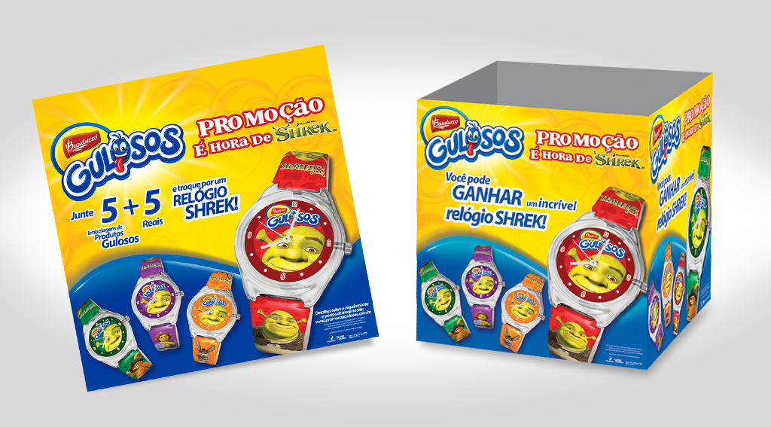

https://www.wipo.int/edocs/lexdocs/laws/es/br/br117es.pdf
http://www.planalto.gov.br/ccivil_03/leis/l8078.htm
http://www.planalto.gov.br/ccivil_03/leis/l8069.htm
http://www.conar.org.br/codigo/codigo.php

